**Name: ______________________________ Date: __________________**

**ATAR 12 HUMAN BIOLOGY**

**ATHBY Task 1: In class Validation Quiz**

1. Using only the materials you will submit for your write-up, complete the discussion. (12 marks)

2. Write a conclusion that summarises the main finding(s) of the experiment. (2 marks)

3. With reference to your results:

a) Draw and correctly label (including the types of neurons) the pathway that controlled your response

during the investigation. (4 marks)

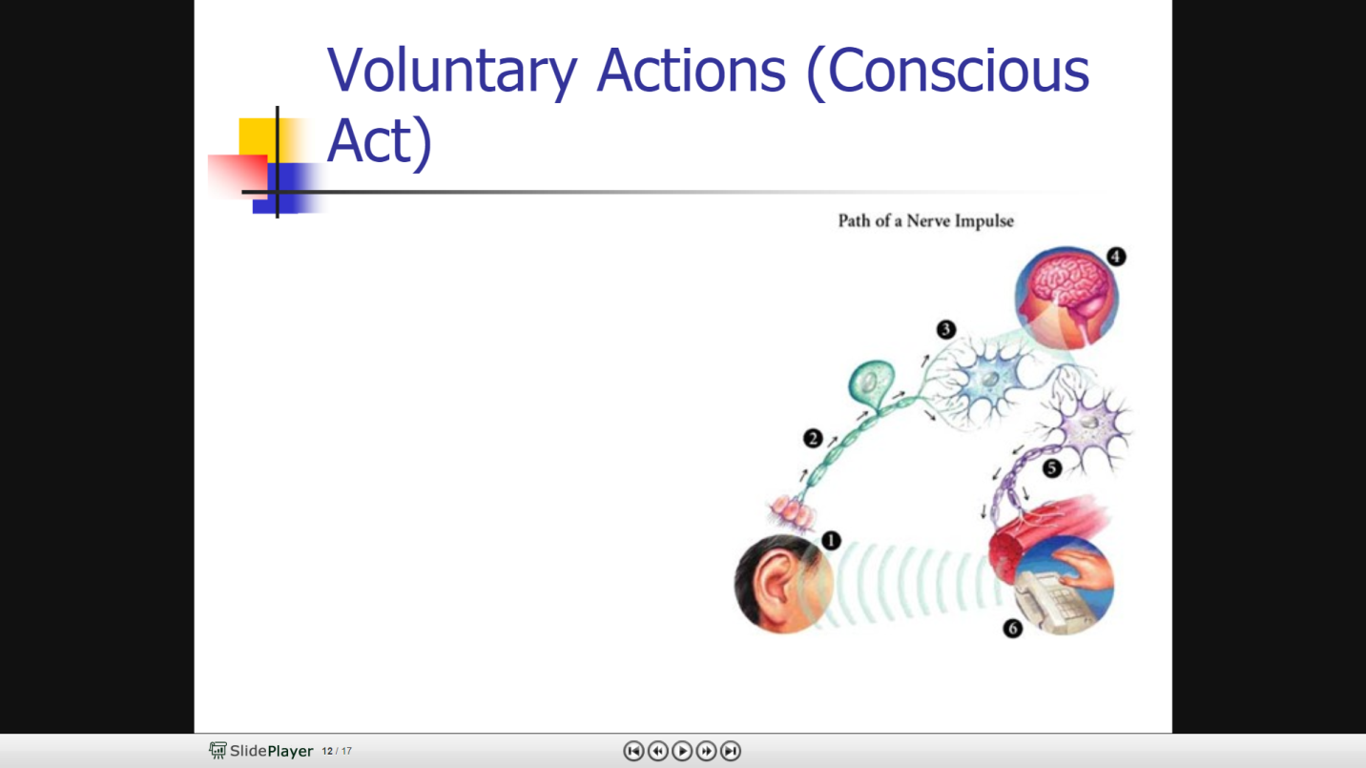One possible mark for each of the below used to give a coherent pathway:

* Stimulus detected by receptor
* Bipolar/Sensory neuron carries message to cerebrum
* Message processed in the appropriate area
* Interneuron relays message to motor neuron
* Motor neuron carries message to motor end plate
* In the effector
* Movement results

        b) Draw and correctly label (including the types of neurons) a spinal reflex arc. (4 marks)

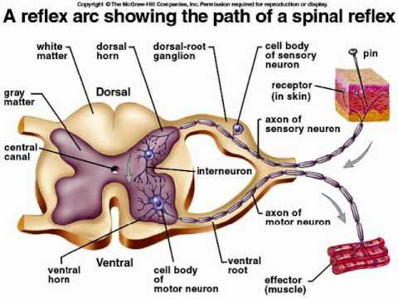

*Any 4 of the following structures labelled:*

*Stimulus*

*Receptor*

*Sensory/Unipolar/Afferent neuron*

*Cell body in dorsal root*

*Interneuron/connector neuron/relay neuron/bipolar*

*Located in grey matter of spinal cord*

*Motor neuron/multipolar/efferent neuron*

*Ventral root contains myelinated axons*

*Motor end plate*

*Direction of flow*

        c) Compare and contrast these two methods of nervous control of movement. (4 marks)

|  |  |  |
| --- | --- | --- |
|  | **Response** | **Spinal Reflex Arc** |
| Speed | Slower | Instantaneous |
| Neurons | Unipolar/Sensory – Interneuron/Connector/Bipolar – Motor/Multipolar | Unipolar/Sensory – Interneuron/Connector/Bipolar – Motor/Multipolar |
| Location of interneuron | Brain – grey matter | Spinal cord – grey matter |

d) Outline the benefits of saltatory conduction to the human body (2 marks)

It saves energy by decreasing the use of sodium-potassium pumps in the axonal membrane (1)

Increased speed afforded by this mode of conduction allows the organism to react and think faster (1)

e) Maddy was seeking to understand why multiple visual stimuli at once did not make her physical

reaction to the stimuli greater. She researched it, and found that the all or none response

explained the LACK of change in physical reaction. Use your knowledge of action potential to

explain to Maddy the all or none response, and how a message is conducted along an axon.

(8 marks)

**All or none** (2 marks max)

Once the threshold of 15mV potential difference is reached, the axon fires. (1)

Regardless of how many mV is applied, the axon will only fire the once. (1)

**Nerve conduction** (max of 6 marks in a coherent explanation)

At rest, the axon membrane is overall positively charged outside (due to Na+/K+/ions) and overall negatively charged (due to large organic negative ions) inside (1)

Depolarisation occurs once the threshold is reached. (1)

Some Na+ channels open, sodium ions flood into the axon. (1)

Na+ movement is not related to the size of the stimulus (all or none response) (1)

This causes the cytoplasm to become overall positively charged (1)

Membrane becomes depolarised (1)

Action potential generated (1)

The Na+ channels close after a short while (1)

Voltage gated K+ channels open (1), moving K+ ions outside of the axon (1) repolarising the membrane (1)

K+ channels remain open for too long, causing the membrane to hyperpolarise (1)

Na+ channels are inactive until resting membrane potential is reached, blocking the axon from transmitting another stimulus. (1)